**Boot Camp Day-1**

**PROGRAM:1**

**Algorithm:**

**Step 1:**Start

**Step 2:** Read the I value

**Step 3:** Initializes the Variables

**Step 4:** Read I value

**Step 5:** A.Repeat the Steps Until it prints upto z value

          B.initializes i=92

**Step 6:** Display ASCII Values

**Step 7:** Stop

**public** **class** ASCII {

public static void main(String args[]) {

        int i,n;

        for(i = 0; i < 26 ; i++) {

         n=('a'+i);

         System.out.print(n);

         if(i<25){

         System.out.print(",");

         }

        }

    }

}

**OUTPUT:**

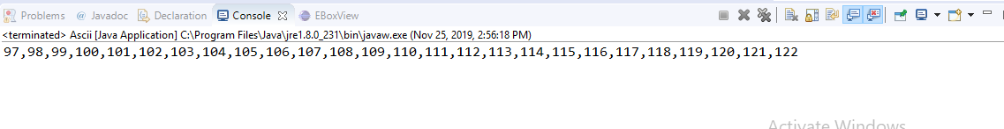

**PROGRAM:2**

**import** java.util.Scanner;

**import** java.util.Scanner;

**public** **class** YoungestOldest{

**public** **static** **void** main(String[] args){

**int** num1, num2, num3, result, temp;

Scanner scanner = **new** Scanner(System.***in***);

System.***out***.print("");

num1 = scanner.nextInt();

System.***out***.print("");

num2 = scanner.nextInt();

System.***out***.print("");

num3 = scanner.nextInt();

scanner.close();

temp = num1 < num2 ? num2:num1;

result = num3> temp ? num3:temp;

System.***out***.println("Oldest friend:"+result+" Years");

temp = num1 < num2 ? num1:num2;

result = num3 < temp ? num3:temp;

System.***out***.println("Youngest friend:"+result+" Years");

}

}

**OUTPUT:**

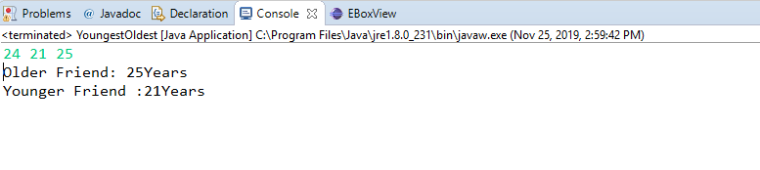

**FLOWCHART:**

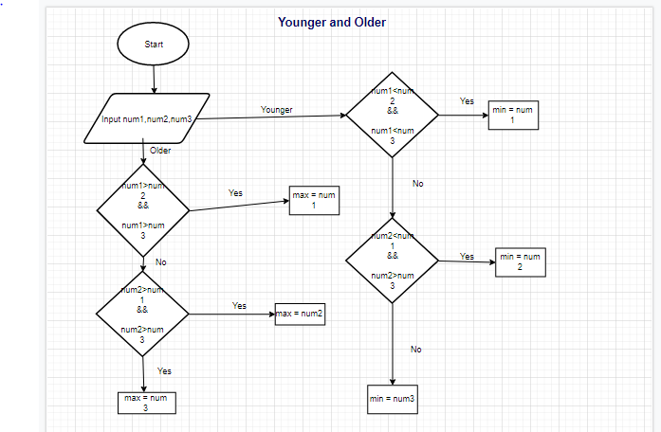

**PROGRAM:3**

**import** java.util.Scanner;

**public** **class** Apples {

**public** **static** **void** main(String[] args) {

**int** xor, and, temp,n=0,m=0;

Scanner sc=**new** Scanner(System.***in***);

System.***out***.println("Number of apples:");

n=sc.nextInt();

System.***out***.println("Number of apples to be added:");

m=sc.nextInt();

and = n & m;

xor = n ^ m;

**while**(and != 0 )

{

and <<= 1;

temp = xor ^ and;

and &= xor;

xor = temp;

}

System.***out***.println("Total number of apples:" +xor);

}

}

**OUTPUT:**

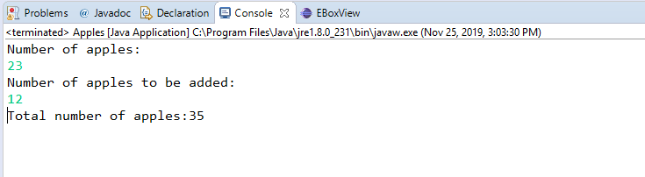

**PROGRAM:4**

**import** java.util.Scanner;

**public** **class** Average {

**public** **static** **void** main(String[] args)

{

**int** n,num,sum=0, i;

Scanner input =**new** Scanner(System.***in***);

**for**(i=1;i<=5; i++)

{

num=input.nextInt();

sum += num;

}

**int** average=(**int**)sum/5;

System.***out***.println(average);

}

}

**OUTPUT:**

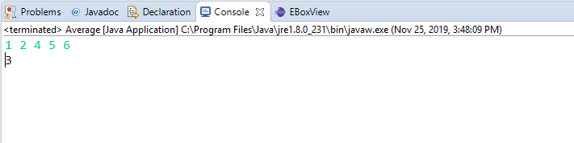

**PROGRAM:5**

**import** java.util.Scanner;

**public** **class** Accept5th {

**public** **static** **void** main(String args[]) **throws** Exception

{

String name, gender;

**int** age;

Scanner SC=**new** Scanner(System.***in***);

name= SC.next();

age=SC.nextInt();

gender=SC.next();

System.***out***.println("Name:"+name+", Age:"+age+" and "+"Gender:"+gender);

}

}

**OUTPUT:**

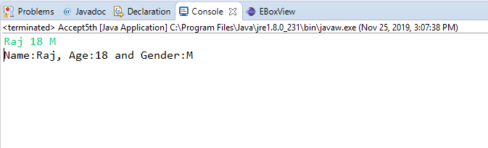

**PROGRAM:6**

**import** java.util.Scanner;

**public** **class** Numberofyear {

**public** **static** **void** main(String args[])

{

**int** m, year, week, day;

Scanner s = **new** Scanner(System.***in***);

System.***out***.print("Input number of days:");

m = s.nextInt();

year = m / 365;

m = m % 365;

System.***out***.println("Number of years:"+year);

week = m / 7;

m = m % 7;

System.***out***.println("Number of weeks:"+week);

day = m;

System.***out***.println("Number of days:"+day);

}

}

**OUTPUT:**

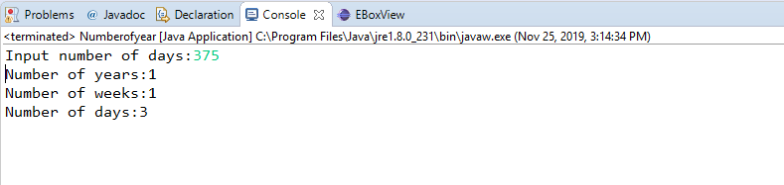

**PROGRAM:7**

**ALGORITHM:**

**Step 1:**Start

**Step 2:**Declare Character type Variable ch

**Step 3**: Read the ch from the User

**Step 4:**For ch, there are 10 possibilities for vowel we need to check i.e. a, e, i, o, u, A, E, I, O and U.

**Step 5**: Write all 10 possible cases for vowels and print "Vowel" for each  case

**Step 6:** If alphabet is not vowel then add a default case and print "Consonant".

**Step 7:** If the case is number than Print Invalid Alphabet

**Step 8:** Stop

**import** java.util.Scanner;

**public** **class** InputAlpha {

**public** **static** **void** main(String[ ] arg){

**boolean** isVowel=**false**;

Scanner scanner=**new** Scanner(System.***in***);

System.***out***.println("Input an alphabet : ");

**char** ch=scanner.next().charAt(0);

scanner.close();

**switch**(ch){

**case** 'a' :

**case** 'e' :

**case** 'i' :

**case** 'o' :

**case** 'u' :

**case** 'A' :

**case** 'E' :

**case** 'I' :

**case** 'O' :

**case** 'U' : isVowel = **true**;

}

**if**(isVowel == **true**) {

System.***out***.println("Input character is vowel");

}

**else** {

**if**((ch>='a'&&ch<='z')||(ch>='A'&&ch<='Z'))

System.***out***.println("Input Character is Consonant");

**else**

System.***out***.println("Invalid data");

} }

}

**OUTPUT:**

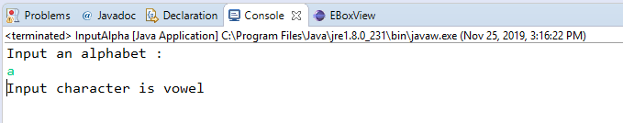

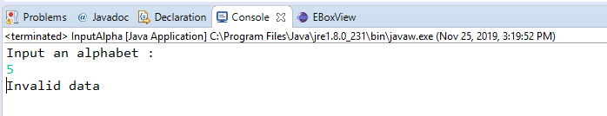

**PROGRAM:8**

**public** **class** QuotientRemainder {

**public** **static** **void** main(String args[])

{

System.***out***.println("Command line arguments are: "+args[0]+" "+args[1]);

**int** dividend=Integer.*parseInt*(args[0]);

**int** divisor=Integer.*parseInt*(args[1]);

**int** quotient = dividend / divisor;

**int** remainder = dividend % divisor;

System.***out***.println("Quotient = " + quotient);

System.***out***.println("Remainder = " + remainder);

}

}

**OUTPUT:**

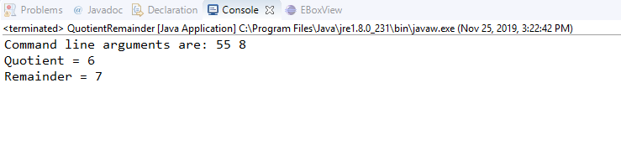

**PROGRAM:9**

**package** Practice;

**import** java.util.Scanner;

**public** **class** Fibonacci {

**public** **static** **void** main(String args[])

{

**int** n;

System.***out***.print("n=");

Scanner sc=**new** Scanner (System.***in***);

**int** a=1;

**int** b=0;

n=sc.nextInt();

**for**(**int** i=0;i<n;i++)

{

System.***out***.print(b);

b=a+b;

a=b-a;

**if**(i<=n-2)

{

System.***out***.print(" ");

}

}

}

}

**OUTPUT:**

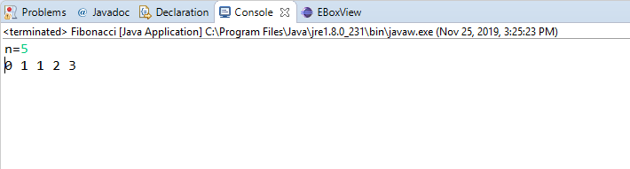

**PROGRAM:10**

**import** java.util.Scanner;

**public** **class** Swap {

**public** **static** **void** main(String args[])

{

**int** x,y;

Scanner sc=**new** Scanner(System.***in***);

System.***out***.println("Input two integers: ");

x=sc.nextInt();

y=sc.nextInt();

System.***out***.println("Pre swap: "+x+" "+y);

x = x+y;

y=x-y;

x=x-y;

System.***out***.println("Post swap: " +x+" "+y);

}

}

**OUTPUT:**

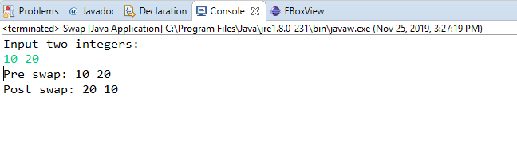

**PROGRAM:11**

**Output:**

**WHILE:**

Compilation Failed

->While should be declared in .java file.

->Incompatible Types : Double cannot be converted to Boolean.

**PROGRAM:12**

**import** java.util.Scanner;

**public** **class** ArmStrong {

**private** **static** **boolean** isArmStrong(**int** num){

**int** res = 0; **int** org = num;

**while**(num != 0){

**int** rem = num %10;

res = res + rem*rem*rem;

num = num/10;

}

**if**(org == res){

**return** **true**;

}

**else**

**return** **false**;

}

**public** **static** **void** main(String args[]){

Scanner sc=**new** Scanner(System.***in***);

System.***out***.println("Input number is:");

**int** num=sc.nextInt();

**if**(*isArmStrong*(num)){

System.***out***.println("Given number is ArmStrong");

}

**else**{

System.***out***.println("not armstrong number");

}

}

}

**OUTPUT:**

